**What Would Happen if the U.S. Withdrew From Nafta**

*The New York Times* - By [Ana Swanson](https://www.nytimes.com/by/ana-swanson) and Kevin Granville - Oct. 12, 2017

President Trump continues threatening to withdraw the United States from the North American Free Trade Agreement, and with negotiations [on rocky ground](https://www.nytimes.com/2017/10/11/business/economy/nafta-trump.html), that risk could soon become reality. Withdrawing from the pact would bring big changes for the economy and for consumers.

Since the pact came into effect in 1994, United States trade with Mexico and Canada has more than tripled, growing more rapidly than American trade with the rest of the world. Mexico and Canada are now the second and third largest exporters to the United States, after China. And the two countries are the leading importers of American products.

Mr. Trump has criticized Nafta for creating an unfair playing field, allowing Mexico to steal jobs from the United States and opening the border to cheap, tariff-free goods. He wants to bring factory jobs back home.

But pulling out of the pact could have unintended economic consequences. Over the past quarter century, Nafta has reshaped the United States economy, and its demise could raise costs for American companies and consumers.

President Trump could easily pull out of Nafta

The Nafta agreement allows any of the countries involved to withdraw six months after notifying the other parties. Congress could oppose a White House decision to withdraw, arguing that the Constitution gives Congress power to “regulate commerce with foreign nations.” Members of Congress could also threaten to stall Mr. Trump’s legislative efforts, like tax reform, in order to stay his hand.

But there is no language in Nafta’s authorizing law passed by Congress that requires Congressional assent before leaving the pact. So Mr. Trump could easily dissolve Nafta with the stroke of a pen.

If he exits, tariffs will rise ...

Under Nafta, the three countries pay nothing on most goods that cross the border. After the United States exits the pact, the tariffs, or taxes, that Canada and Mexico put on its goods would rise. For some goods, tariffs could go as high as 150 percent. That would cause prices to spike and cut into company profits.

All three countries are members of the World Trade Organization, so tariffs could revert to those levels. Currently, they are 0 percent for most goods under Nafta.

After Nafta, the W.T.O. rules would apply to trade between the United States and Mexico. Tariffs on agricultural exports to Mexico are particularly costly, including a 15 percent tariff on wheat, a 25 percent on beef and a 75 percent tariff on chicken and potatoes. But goods like soap, fireworks, handbags and many articles of clothing face tariffs of 15 to 20 percent. Mexican goods would, in turn, face an average United States tariff of 3.5 percent.

Trade experts are debating whether Canada and the United States would revert to a pre-existing free-trade agreement between the two countries that was superseded by Nafta. If not, United States exporters would face an average W.T.O. tariff in Canada of 4.2 percent, again with much higher rates on some goods, including 27 percent for beef and 18 percent for most apparel.

... supply chains would be shaken up ...

Companies have spent decades building up complex supply chains that snake across North America’s borders to take advantage of differing costs and resources. American automakers are especially reliant on parts imported from overseas — but other industries, including agriculture, energy and retail would also be affected. These trading relationships help keep the price of the final product competitive with other major global manufacturing hubs in Asia and Europe.

**:: Automakers ::**

The automotive sector in the three countries are tightly linked, exporting and importing billions of dollars of parts. Last year the United States imported 1.6 million vehicles from Mexico. But about 40 percent of the value of the components in those vehicles came from the United States.

**:: Apparel ::**

American textile makers shipped more than $11 billion in goods to Canada and Mexico last year, according to the National Council of Textile Organizations. The tariffs that the three countries have on clothes under the W.T.O. are relatively high, often 18 to 20 percent.

**:: Agriculture ::**

Nafta opened major markets to United States farmers. American corn now is sold in Mexico, a market it had previously been excluded from. Mexican avocados, tomatoes and other fresh fruits and vegetables are now commonly found in United States groceries, especially during the winter growing season.

**:: Medical Devices ::**

The United States imports about 30 percent of its medical devices and supplies, and Mexico is a leading supplier. And some major American manufacturers have opened factories in Mexico in recent years.

... and consumers could feel the pinch

Higher tariffs would push prices up on a range of goods. Many vehicles in the United States are manufactured in Mexico, like the Ram Heavy Duty pickup truck and Ford Fusion, while Dodge Challengers and Chevrolet Equinoxes are assembled in Canada. Prices would also surge for the Mexican fruits and vegetables that fill United States grocery stores.

The White House argues that a better trade deal would support companies making goods in America, thus creating more American jobs. That would likely be true in some cases. The American market is a very large one, so some companies would probably relocate production to the United States to avoid paying tariffs.

But other companies might decide its cheaper to relocate their manufacturing out of North America entirely. They could, for instance, produce goods entirely in China and then pay the United States tariff instead. The United States tariff on passenger cars is only 2.5 percent, so if Nafta falls apart it may be more cost-effective for companies to make cars in Asia.

But the alternatives are mixed

A withdrawal from Nafta could set the stage for a new trade pact with the three countries, or perhaps a bilateral trade deal with Mexico and an updated agreement with Canada. But following a contentious collapse of the agreement, Canada and Mexico may be in no mood to negotiate.

That could put the United States at a disadvantage.

Mexico and Canada could remain members of Nafta and continue trading on its terms. It’s important to note that the European Union has signed free trade agreements with both Mexico and Canada that lowered tariffs on most products to zero, meaning that European companies may have an edge over American competitors in those markets.

In the aftermath of Nafta, the most likely scenario is that Canada and Mexico would push ahead with trade agreements with other countries. Both are still in discussions to pass the Trans-Pacific Partnership, a multicountry trade pact that President Trump withdrew the United States from on his fourth day in office. That deal would give Canada and Mexico tariff-free access to several lucrative markets, including Japan.

**US hikes tensions in NAFTA talks with call for 'sunset clause'**

* Washington increased tensions in talks to renew the North American Free Trade Agreement by proposing any new deal be limited to five years.
* The proposal for a so-called sunset clause — just one of a series of U.S. initiatives that are opposed by NAFTA partners Canada and Mexico.
* Two sources with direct knowledge of the talks described the atmosphere as "horrible" and highly charged.

*CNBC.com* - Jonathan Ernst | Reuters – October 13, 2017

President Donald Trump welcomes Canada's Prime Minister Justin Trudeau on the South Lawn before their meeting about the NAFTA trade agreement at the White House in Washington, U.S. October 11, 2017.

Washington has dramatically increased tensions in talks to renew the North American Free Trade Agreement by proposing that the lifespan of any new deal be limited to five years, people familiar with the negotiations said on Thursday.

The proposal for a so-called sunset clause — just one of a series of U.S. initiatives that are opposed by NAFTA partners Canada and Mexico — only served to increase uncertainty about the future of the deal.

Two sources with direct knowledge of the talks described the atmosphere as "horrible" and highly charged.

The U.S. side proposed the sunset clause late on Wednesday during the fourth of seven scheduled rounds to update the rules governing one of the world's biggest trade blocs, said two officials, who asked not to be identified because the talks are confidential.

The Trump administration says the clause, causing NAFTA to expire every five years unless all three countries agree it should continue, is to ensure the pact stays up to date.

But Mexico and Canada insist there is no point updating the pact with such a threat hanging over it, arguing the clause would stunt investment by sowing too much uncertainty about the future of the agreement.

"It's a source of total uncertainty," said one of the NAFTA government officials.

Speaking in Mexico City, Finance Minister Jose Antonio Meade said the government was working on plans to alter tariffs and identify substitute markets in case the NAFTA talks failed.

His remarks and the tension around NAFTA helped push the peso down 1 percent against the U.S. dollar to a five-month low.

U.S. President Donald Trump says NAFTA, originally signed in 1994, has been a disaster for the United States and has frequently threatened to scrap it unless major changes are made.

Business and farm groups say abandoning the 23-year-old pact would wreak economic havoc, disrupting cross-border manufacturing supply chains and slapping high tariffs on agricultural products. Trade between the United States, Canada and Mexico has quadrupled under NAFTA, now topping $1.2 trillion a year.

In addition to the sunset clause, the United States wants to boost how much North American content autos must contain to qualify for tax-free status and eliminate a dispute settlement mechanisms that Canada insists must stay.

Some trade observers said it is difficult to see how negotiators could reach an agreement given U.S. demands that many see as non-starters.

The head of Unifor, Canada's largest private sector labor union, said it was clear the United States did not want a deal.

"NAFTA is not going anywhere. This thing is going into the toilet," Jerry Dias told reporters on Thursday.

Despite clear signs of impatience from Canada in particular, U.S. negotiators have yet to submit their proposal on rules of origin for the auto sector. That looked unlikely to come before Friday, another official familiar with the talks said.

Trump on Wednesday repeated his warnings that he might terminate the pact and said he was open to doing a bilateral deal with either Canada or Mexico.

He was speaking alongside Canadian Prime Minister Justin Trudeau, who later said Canada was "braced" for Trump's unpredictability.

**NAFTA's Members Head Back To The Table**

*Forbes.com* - [Stratfor](https://www.forbes.com/sites/stratfor/) , Contributor – October 10, 2017

**Highlights**

* *Over the next few rounds of negotiations on the North American Free Trade Agreement, Canada, Mexico and the United States will present more drafts of proposals to revise the deal than they have during previous discussions.*
* *The United States will propose the most contentious reforms, such as measures to increase the amount of U.S.-produced content in products imported from Mexico and Canada under NAFTA.*
* *The negotiations are unlikely to break down, despite the controversial issues the next round of talks will cover, though they probably will take awhile to reach their conclusion.*

Canada, Mexico and the United States are drawing their battle lines for the fourth round of [negotiations to revise the North American Free Trade Agreement](https://admin.stratfor.com/node/282852). And the differences in their priorities for the talks, scheduled for Washington during Oct. 11-15, are becoming even clearer. The negotiations will reach their apex in the fourth round, but they will hit plenty of bumps along the way. As the signatory countries address the most difficult items on their agendas, they will run up against one another's imperatives, making compromise all the more challenging.

**Getting in Gear**

For U.S. President Donald Trump's administration, the main focus of the talks will be on reducing the United States' bilateral trade deficit with Mexico and boosting its exports to the rest of the bloc. The United States is expected to propose increasing regional content requirements, the rules that govern the percentage of a product's added value that must come from within NAFTA, from 62.5 percent to 85 percent to close the gap between its imports and exports. It is also expected to propose a new stipulation -- the first of its kind in a multilateral trade deal -- requiring that 50 percent of a good's content come from the United States to qualify for NAFTA benefits.

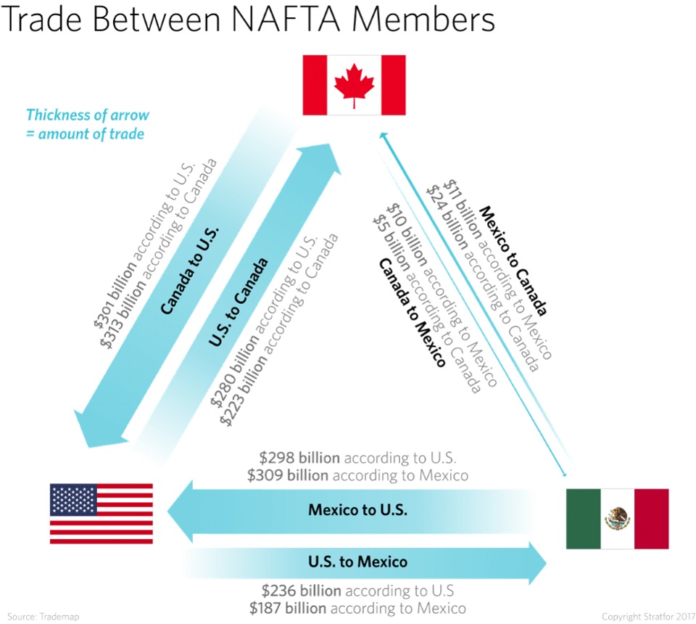The automobile sector, which accounts for $54 billion of the $66 billion U.S. deficit, is the chief target of these proposals. But the vast majority of U.S.-based automotive companies will object to implementing the measures. The automotive supply chains in the United States, Canada and Mexico, after all, are so closely integrated that suddenly changing regional content requirements would cause major problems across the bloc. Furthermore, it's unclear whether higher content requirements will help the U.S. automotive sector in the long run. American-made cars and components aren't as competitively priced as they once were. Many firms may sooner forgo the perks of NAFTA and pay the modest 2.5 percent tariff the United States applies to many light-duty vehicles than take on the expense of complying with the revised rules. And automakers won't be the only ones grumbling in the United States. Others already have criticized U.S. Trade Representative Robert Lighthizer for ignoring the procedure for raising issues to address in the negotiations. Though Lighthizer has the lead in the trade talks, his office must clear the U.S. position with other government agencies before presenting it to Mexico and Canada. Lighthizer has responded to the complaints that he has bypassed the proper channels by saying that the government eventually will come together on the various issues at stake. So far, however, some of Lighthizer's demands, such as proposals to institute a sunset clause or an automatic renegotiation trigger in NAFTA and to change its investor-state dispute settlement mechanism, are still points of contention in the United States.

**On the Other Sides**

Outside the United States, many of the proposals the White House has or is expected to put forth in the fourth round will be no less controversial. Canada and Mexico, for example, probably will object to the sunset clause if it comes up again, having shot it down when the United States first floated the idea. The U.S. administration's plans for the agricultural sector are bound to raise some hackles, too. Talk of imposing seasonal trade barriers on certain crops during their harvest season to [protect U.S. agriculture](https://admin.stratfor.com/node/278983) could be worrisome for Canada and Mexico should their harvests coincide with those of the United States. In addition, Canada will probably bristle at Washington's demands on its [closely guarded dairy sector](https://admin.stratfor.com/node/284202).

Ottawa has several concerns about Washington's agenda going into the talks, though, compared with Mexico City, it won't take much heat from the United States over trade deficits. Besides its desires to keep the supply controls on its dairy sector in place, the Canadian government wants to preserve the current dispute resolution mechanism under Chapter 19. The provision enables companies to avoid domestic courts when appealing anti-dumping and countervailing duty cases. And considering the [220 percent duty the United States levied on some Canadian airplane exports](https://admin.stratfor.com/node/283906) last month -- to which it added an additional 80 percent tariff earlier this month -- maintaining the mechanism is a big priority for Canada.

Mexico, meanwhile, is getting ready to stand up to the United States. On Oct. 5, a group of senators from President Enrique Pena Nieto's Institutional Revolutionary Party outlined the six items that they will refuse to agree to in the new NAFTA. Most of the issues they highlighted are measures the United States has proposed to add or alter, including the sunset clause, the content level requirements, the Chapter 19 dispute mechanism and the seasonal protections on produce. Mexico's threat to vote against an agreement that addresses these provisions will make for contentious negotiations. The Pena Nieto administration is trying to reach a deal on NAFTA before the next administration takes power and a new crop of legislators enters the Congress of the Union late next year. If the United States pressures Mexico to accept an agreement that crosses its six red lines before the power transition takes place, the deal could die in the Mexican legislature. That puts the negotiators in a tough position heading into the fourth round.

No matter how heated they get, however, the next round of talks won't break down. Mexico, Canada and the United States all agree on at least one thing: that NAFTA's collapse would be devastating for all parties involved. But reaching a compromise won't be easy with so many disparate priorities to navigate, nor will it be quick. The talks could extend deep into 2018, at which point they would risk complications not only from the [Mexican elections slated for next summer](https://admin.stratfor.com/node/278930) but also from U.S. midterm elections in the fall. In the meantime, the extent of the differences between NAFTA's three members will come to light as the fourth round of negotiations gets underway.

*This article was originally published by* [*Stratfor Worldview*](https://worldview.stratfor.com/)*, a leading geopolitical intelligence platform and advisory firm based in Austin, Texas.*

**US demands raise fears that leaving NAFTA could hurt economy**

*The Washington Post* - By Paul Wiseman - October 11, 2017

WASHINGTON — The North American Free Trade Agreement is in its 23rd year. But there are growing doubts that it will survive through its 24th.

President Donald Trump has threatened to withdraw from the agreement if he can’t get what he wants in a renegotiation. But what he wants — from requiring that more auto production be made-in-America to shifting more government contracts to U.S. companies — will likely be unacceptable to America’s two NAFTA partners, Mexico and Canada.

Round 4 of NAFTA talks began Wednesday in Arlington, Virginia. In a sign of how contentious things could get, the countries extended the negotiations for two extra days, through Tuesday.

“What is the administration going to do? Are they going to be patient and work through these things?” asks Phil Levy, senior fellow at the Chicago Council on Global Affairs. “Or are they going to take this as a pretext and say, ‘We tried negotiations; they failed. Now we need to blow this up?’ ”

Blowing up the deal appears to be Trump’s favored choice. On the campaign trail, he called NAFTA a job-killing disaster. And in an interview with Forbes magazine published Tuesday, Trump said: “I happen to think that NAFTA will have to be terminated if we’re going to make it good. Otherwise, I believe you can’t negotiate a good deal.”

Levy pegs the chance of NAFTA’s survival at less than 50 percent.

The end of NAFTA would send economic tremors across the continent. American farmers depend on Mexico’s market. Manufacturers have built complicated supply chains that cross NAFTA borders. Consumers have benefited from lower costs.

NAFTA erased most trade barriers along the United States, Canada and Mexico and led to an explosion in trade between the three countries. But critics say the pact sent hundreds of thousands of U.S. manufacturing jobs to Mexico, where corporations took advantage of low-wage labor.

Before the renegotiation began in August, many business and farm groups hoped the Trump administration would settle for tweaking rather than abandoning the trade deal — updating it, for example, to reflect the rise of e-commerce. But U.S. Trade Rep. Robert Lighthizer declared at the outset that the U.S. wouldn’t be satisfied with anything but a major overhaul.

So the administration has been seeking to ensure that more auto production be made in America to receive NAFTA benefits, that more government contracts in the NAFTA bloc go to U.S. companies and that NAFTA expire unless the countries agreed every few years to extend it. It also wants to scrap a dispute-resolution process favored by Canada. Those proposals are considered poison pills by Canada and Mexico.

Visiting Washington on Wednesday, Canadian Prime Minister Justin Trudeau told reporters that he thinks “it is very important and very possible to get a win-win-win” from the NAFTA talks. But he acknowledged that “we have to be ready for anything — and we are.”

The negotiators are under pressure to reach a deal this year — before presidential elections in Mexico and midterm elections in the United States raise the political temperature in 2018. “The administration set itself the task of doing a really radical overhaul and having it done by Christmas,” says Levy, a former trade adviser to President George W. Bush. “I’m not surprised that Ambassador Lighthizer hasn’t been able to square that circle.”

Gary Hufbauer, senior fellow at the Peterson Institute for International Trade, says Trump “very likely” has the legal authority to withdraw from NAFTA on his own if talks collapse. But Congress can fight back. Lawmakers could pass a resolution calling on the president to obtain congressional authority before invoking the NAFTA clause that lets countries pull out. They could also threaten to block the president’s agenda unless he secures congressional approval to withdraw.

If the United States left NAFTA, trade barriers to Canada and Mexico would pop back up. Some of the tariffs wouldn’t be especially high. But Mexican tariffs on many American farm products could soar — to as high as 37 percent on corn, for example, notes Caroline Freund, a senior fellow at Peterson.

For that reason, many agricultural lobbies and lawmakers from farm states have urged the administration to “do no harm” in the NAFTA talks.

Daniel Ujczo, a trade lawyer with Dickinson Wright PLLC, predicts that Canada and Mexico would likely call a timeout if the United States insists on pushing contentious proposals. “The Canadian and Mexican strategy will be to take a pause,” he says, and “allow the U.S. domestic process to play itself out” with business and farm groups and many lawmakers rising to defend NAFTA.

NAFTA supporters are already rallying. In a speech Tuesday in Mexico City, Thomas Donohue, president of the U.S. Chamber of Commerce, vowed: “We’re going to fight like hell to protect the agreement.”